1. Install AutoCAD and ArcMap.
2. Preprocess the CAD drawing.
   1. Prepare the original CAD drawing file and copy the drawing to a new file.

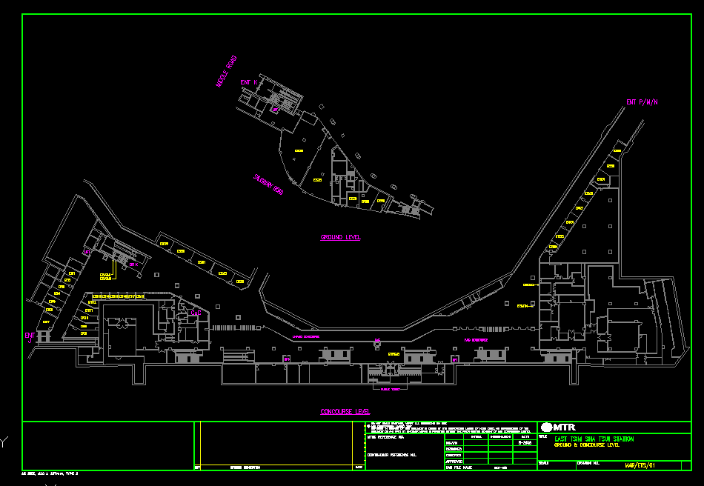

* 1. Remove the frame of the CAD drawing and convert the drawing to white color.

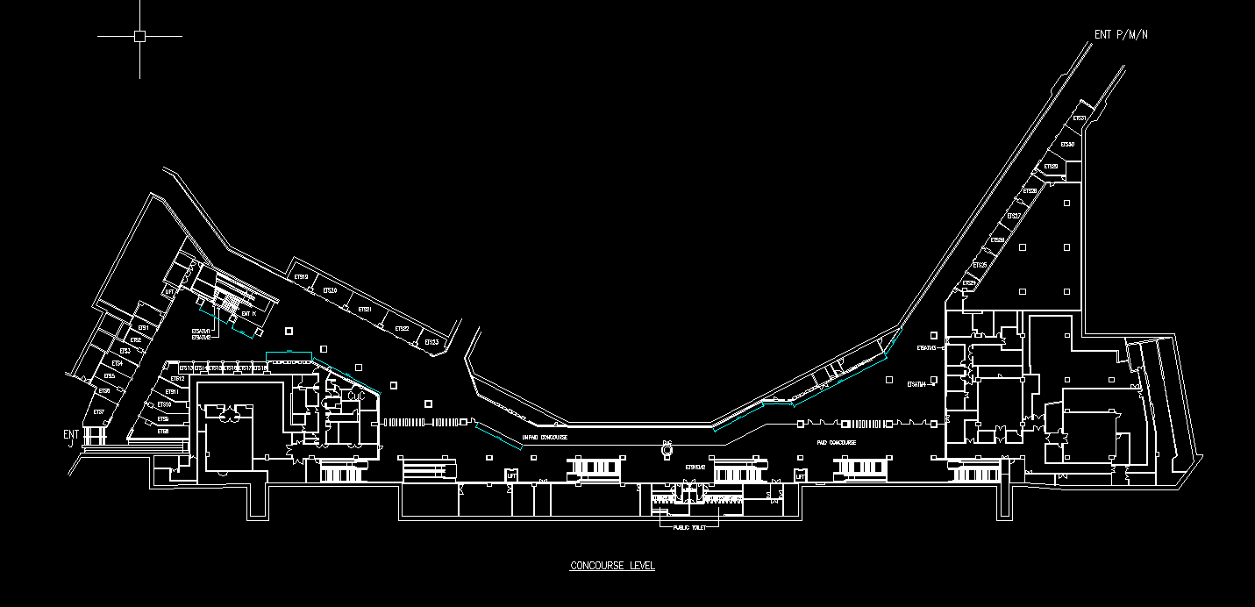

1. Find the target location (at least latitude and longitude of 4 geographic points) of the MTR station using Google map.

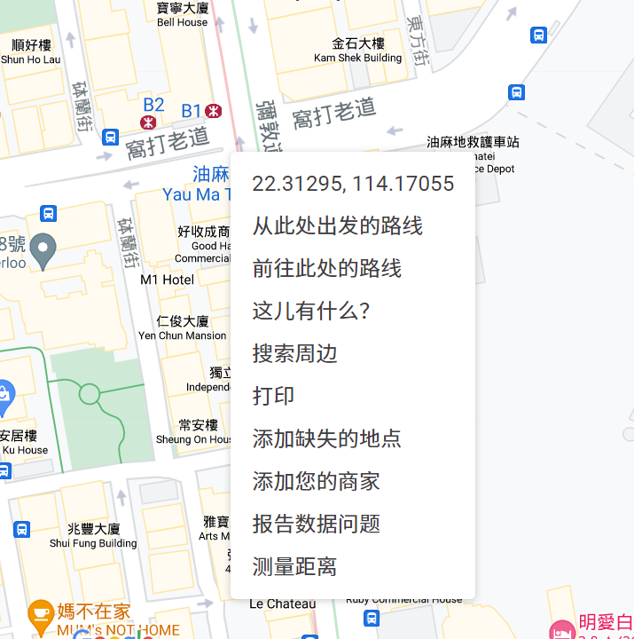

1. Using “point” command in AutoCAD to put the 4 geographic points in AutoCAD and then connect these 4 points together to a polygon.
2. Using “move” and “scale” function of AutoCAD to move the drawing into the target place.

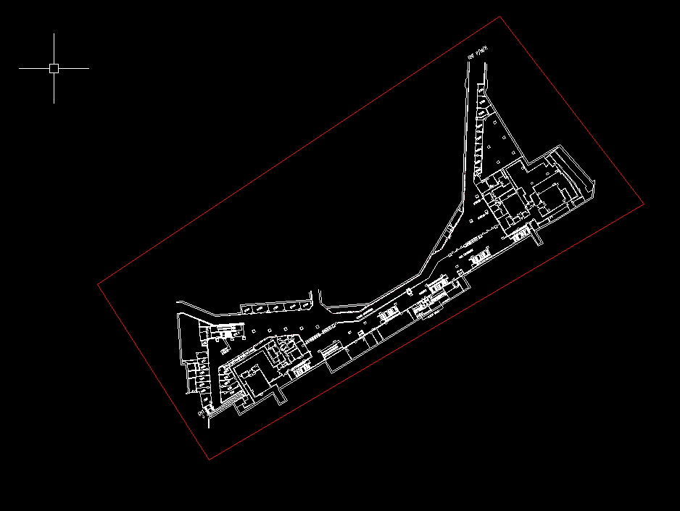

1. Select the words, characters and numbers elements in the CAD drawing, using “TXTEXP” command to convert them into the drawing elements. Remove the reference geographic points and lines.
2. Using “create block(创建块)” function to convert the CAD drawing into the block element.

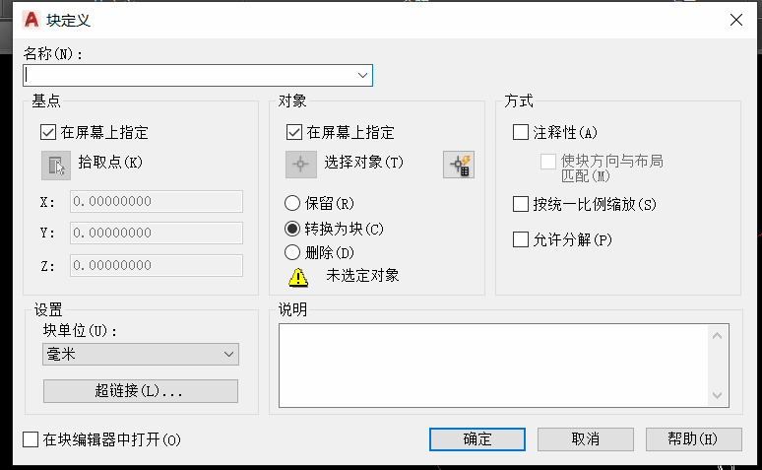

1. Open the Software ArcMap
2. Using “CAD to Geodatabase” in the system toolbox. Import the processed CAD file. The setting is shown below.

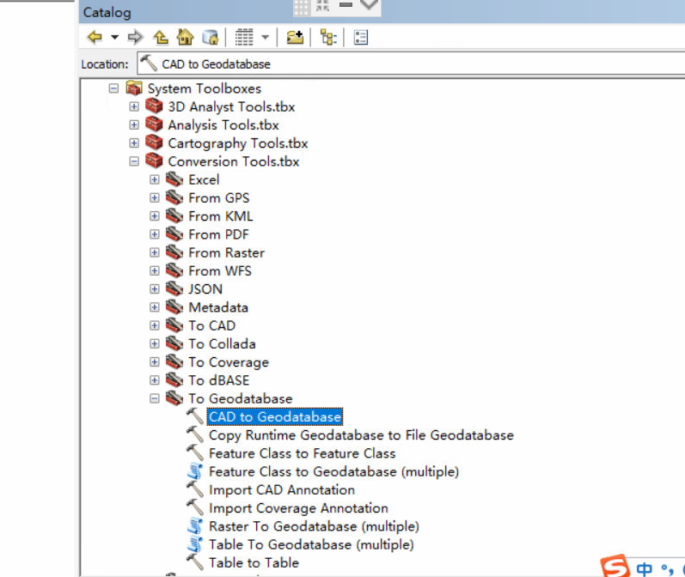

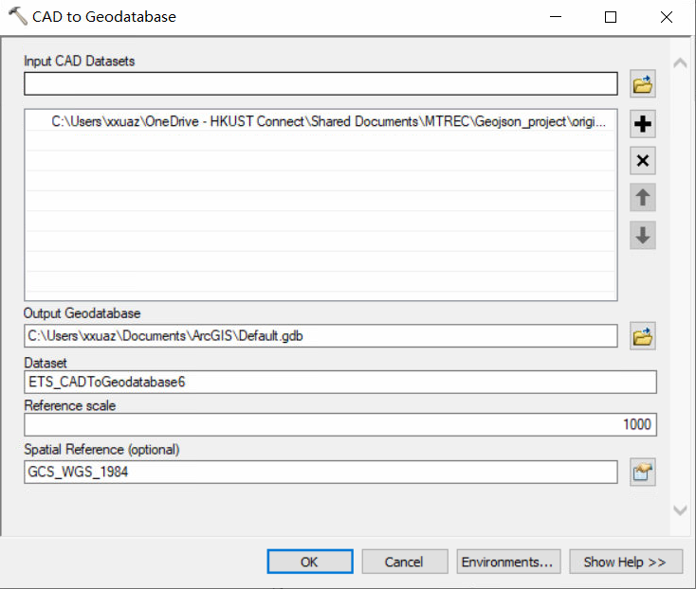

1. Once the process is finished, export the Polyline data to “shp” format. The setting is shown below.

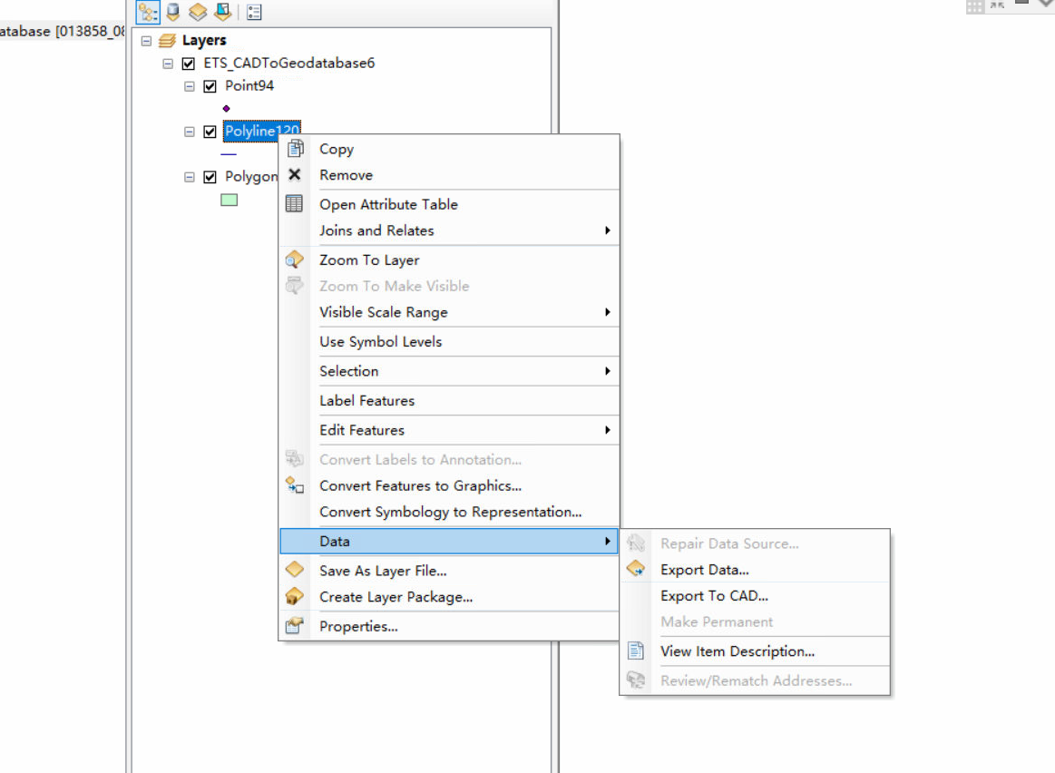

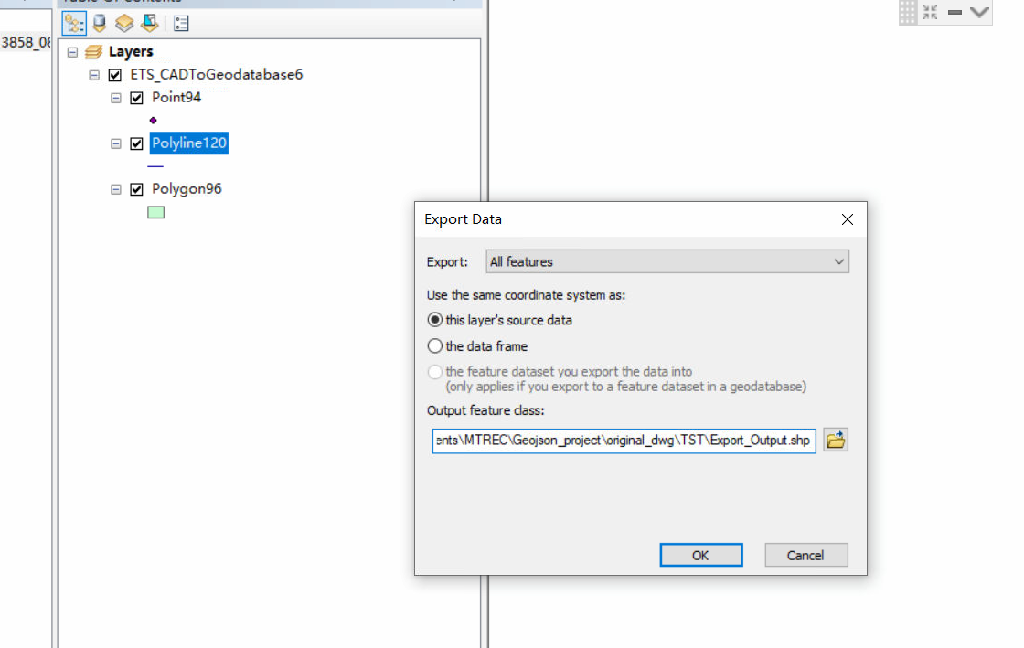

1. Using “Feature to JSON” function to generate the GeoJSON file from “shp” file. Remember to click the GeoJSON (optional) 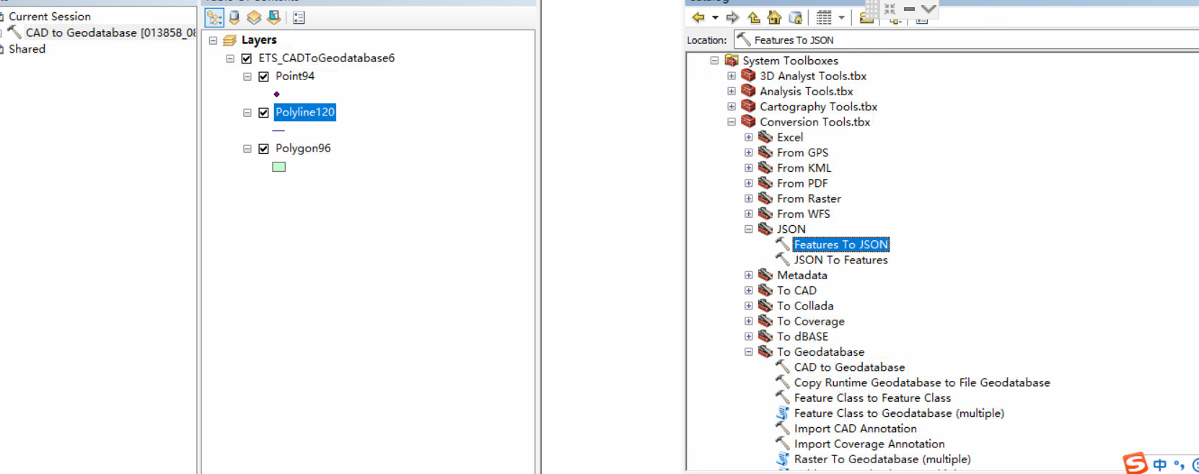

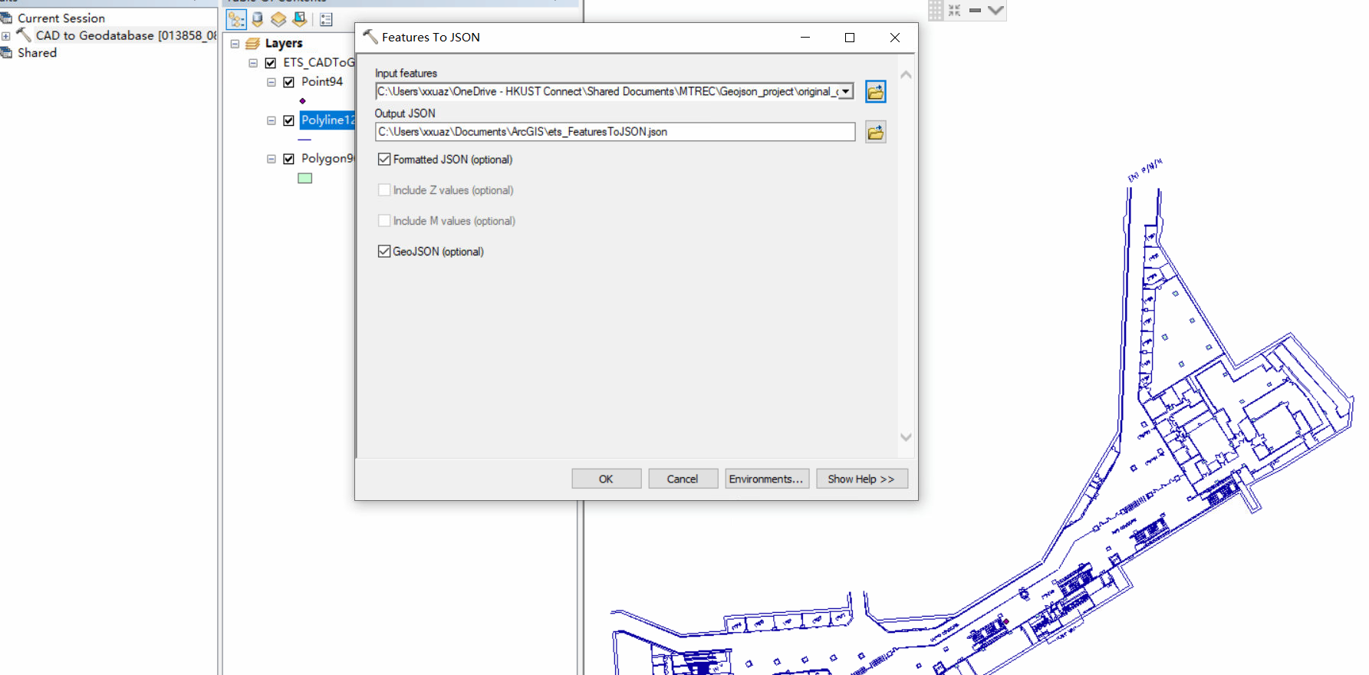

1. Using the mapbox tool to import the GeoJSON file, open the file, delete the “crs”:{} element, and evaluate its location using Mapbox web tool: <https://studio.mapbox.com/datasets/>. If the location is not in the right place, please refer to step 5 and adjust the location of the CAD drawing (move, rotate or scale).

